

Prototype 1 Report (3)

Members:

Justin Goulet, Chris Larsen, Mikal Callahan, Brock Corbett

Table of Contents

**Executive Communication** **5**

Summary of Accomplishments: 5

For Successful Completion of phase: 5

Accrued Cost for phase: 5

Estimated Cost for phase: 5

Cost to Date: 5

Statement of Business Context: 6

Statement of the Customer's Business Problem: 6

Statement of Project Proposal 6

Statement of Deliverables 6

What Medium Will the Product Be Delivered In 6

Outline of Project Measures of Success 6

**Workflow Representation:** **8**

**Initial Project Cost Tracking Chart** **12**

**Project Plan** **13**

**Statement of the Deliverables** **13**

Estimated Costs - Prototype 2 Due Date: 4/13/17 14

Resources Outline 14

What resources we will need from Northrop Grumman: 14

What resources we are supplying: 14

What resources we will need from the instructor: 14

Gantt Chart / Task List 14

**Team Norms** **15**

Reliability 15

Commitment 15

Communication 15

Common Goal 15

Usrey, Thomas (Ty)

Northrop Grumman

16765 W. Bernardo Dr.

San Diego, CA 92127

Dear Mr. Usrey,

As we progress through our project, our team would like to update you on our current progress.

Thank you for allowing our meeting date to be changed due to team availability. We appreciate your ability to work with us over our Spring Break to ensure we are on the correct path and to provide you with project updates.

Now that we have completed our first prototype, we are hard at work to better optimize the final product per your requirements. We have our current progress posted [here](https://jstngoulet.github.io/vorteksolutions), with the overview display shown first and the ‘Toggle View’ button will display the layout shown in our meeting.

In our next phase, we are working to allow 1 (one) or 2 (two) themes for the existing workflow, with the ability to switch for demonstration purposes. These themes will include the topics mentioned in our last meeting such as: SVG instead of images, a basic admin/user design for one theme, and will include the modified changes (upon approval) of the JSON object to distinguish the different views.

There will also be user manual for both the developers and users who will be using our widget. This User Manual will be written in 2 (two) different forms: HTML for basic users and a MS Word Document for developers. The user-side manual will include images and general use documentation while the developer documentation will include in-depth documentation pertaining to each method and file structure.

So far, our project has incurred an approximate cost of $7,890.00 and an estimated completion cost of $11,175.00 (breakdown in following pages).

We thank you for allowing us to work with you on this project and will contact you soon regarding our next meeting.

Thank You,

Justin Goulet

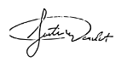

Project Manager / Lead

[VortekSolutions.CIS@gmail.com](mailto:VortekSolutions.CIS@gmail.com)  CC: Dr. Shaun-Inn Wu

I                                                    (print), approve the current project and continuation under the predetermined terms by the Vortek Solutions team, will provide any non-confidential materials that contributes to the overall success of the project and will allow Vortek Solutions to manage all deliverables set by the project sponsor.

Client Signature: _____________________________ Date: ____ /____ /________

# Executive Communication

## Summary of Accomplishments:

* Further Defined Requirements:
  + We will be creating two user manuals:
    - Development user manual written in Microsoft Word
    - Standard user manual written in html
* Discussed Design and Implementation Constraints:
  + Total freedom with design (sans previously discussed colors and symbols)
* Discussed Security Requirements:
  + Any approved libraries should be stored locally in the project instead of accessed via CDN
* Proposed modification of JSON Structure:
  + Suggested node be “wrapped” by a workflow object to contain each node.
  + Pending Approval
* Discussed Design:
  + Two views (admin and user)
  + Admin may modify workflow and states
  + User may just view workflow
  + Proposed “admin” tag on attributes
  + SVG or at least vector based is preferreds

## For Successful Completion of phase:

* We will have a working prototype of the workflow object which includes:
  + The ability to switch between admin and user
  + The replacement of images with SVG elements
* Development and user manuals
* Modified JSON object will be implemented (upon approval)

## Accrued Cost for phase:

Consultation Fee ($35/hour):

**1 hour * $35 = $35**

Labor Fee ($25/hour):

**137 hours * 25 = $3,425**

**Total = $3,425+$35 = $3,460**

$3,460/4 team members = **$865 per employee**

Estimated Cost for phase:

Consultation Fee ($35/hour):

**1 hours * $35 = $35**

Labor Fee ($25/hour):

**120 hours * 25 = $3,000**

**Total = $3,000+$35 = $3,035**

$3,035/4 team members = **$758.75 per employee**

## Cost to Date:

Consultation Fee ($35/hour):

**4 hours * $35 = $140**

Labor Fee ($25/hour):j

**310 hours * $25/h = $7,750**

**Total = $7,750 + $140 = $7,890**

$7,890/4 team members = **$1,972 per employee**

**Application Development**

## **Statement of Business Context:**

Northrop Grumman has existing systems related to their current manufacturing workflows. These systems run in a web browser showing statistics and information related to specific workflows. Created statistics are visualized in charts, or Visio style diagrams, which are not always easily read (especially on devices of various screen sizes such as the tablets used by upper management). The statistics and other pieces of information related to the workflows are then used in decision making at various levels throughout the organization.

## **Statement of the Customer's Business Problem:**

Northrop Grumman is in need of a versatile widget that would allow them to monitor their current workflow in an easy to process but highly descriptive manner. Currently the employees get this information printed out on a piece of a paper, which makes it inconvenient to deduce more information from. There’s a lot more information that would be of use to the employees given that it was more accessible.

## **Statement of Project Proposal**

We propose a widget that will be able to receive multiple workflow objects and render it in the multiple browsers that Northrop Grumman supports. The widget will also be able to be styled using CSS and have the ability to add, update and edit a workflow’s state.

## **Statement of Deliverables**

The deliverables will be:

* The final widget which will:
  + Be an executable, locally run widget, which interprets JSON data containing information of a specific workflow
  + Display workflows multiple workflows in a visual manner
  + Run on IE11+, Firefox 45+ and Edge
* IEEE SRS Documentation
* Developer's manual in Microsoft Word format
* User’s manual in html
* Source Code

## **What Medium Will the Product Be Delivered In**

Source code that our clients at Northrop Grumman will be able to compile and run on their local machines via web browser (IE11+, Edge, Firefox 45)

## **Outline of Project Measures of Success**

JAD 1 - Establish Requirements

JAD 2 - Finalize Requirements

Prototype 1 - Basic widget implemented to receive JSON data

Prototype 2 - Static Widget (i.e. can manually update values of Workflow modules, switch between admin and user)

Final Deliverable - Dynamic Widget (i.e. widget is dynamically changed based on form input)

Workflow Representation:

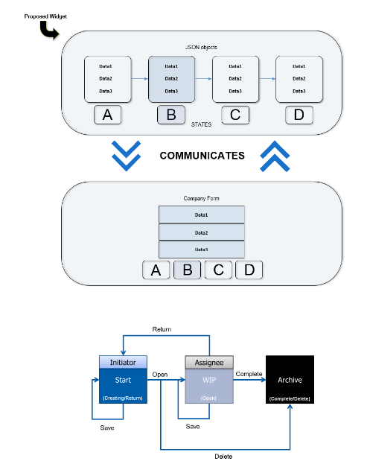

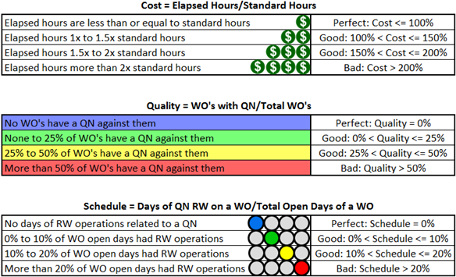

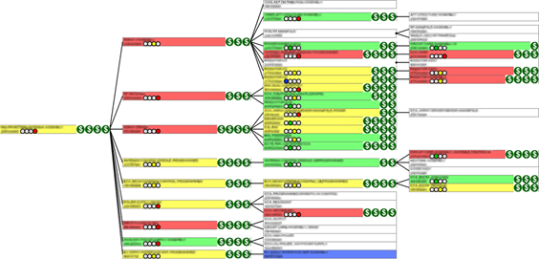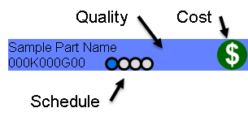

# 

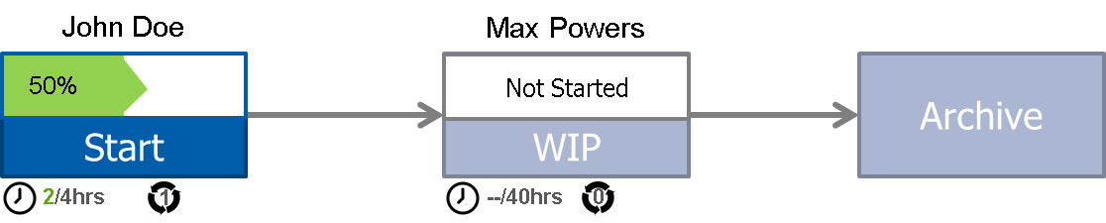

Requirements Matrix

|  |  |  |
| --- | --- | --- |
| **Requirements** | **Description** | **Task**  **Number** |
| **Research** | Explore Javascript libraries that will fulfill requirements and provide necessary functionality. | R1 |
| **Design** | Define requirements for widget and construct basis for further development. | R2 |
| **Development** | Widget will accept nested JSON inputs, UI will dynamically adjust to tree hierarchy and run on previously defined browsers. | R3 |
| **Documentation** | Necessary documentation will be accustomed for future development on widget. | R4 |
| **Error Handling** | Widget must be able to handle incomplete JSON data. | R5 |

Task Schedule

|  |  |  |  |
| --- | --- | --- | --- |
| **Task** | **Task #** | **Project ID** | **Implemented**  **(Y/N)** |
| **Research** | **R1** |  |  |
| Analyze 5+ Javascript libraries | T1 | 11 | Y |
| **Design** | **R2** |  |  |
| Define requirements for proposed widget | T2 | 30 | Y |
| Wireframe Development | T3 |  | Y |
| **Development** | **R3** |  |  |
| Widget will be created with only ID and name passed to it | T4 | 48 | N |
| Render projected workflow steps | T5 | 49 | Y |
| Render workflow info (project name, date started, etc) | T6 | 50 | N |
| Render workflow step linkages | T7 | 52 | Y |
| Allow workflow’s current state to be changed to a different state | T8 | 51 | N |
| Allow additional state(s) to be added to the workflow | T9 | 53 | N |
| Allow widget to be themed with CSS | T10 | 54 | N |
| Allow states to be deleted | T11 | 55 | N |
| The widget shall run on Microsoft Internet Explorer 11+, Edge, and Firefox 45+; with little variation in layout, style, or functionality | T12 | 56 | N |
| **Documentation** | **R4** |  |  |
| Develop User Manual for created portions | T13 | 44 | N |
| Develop code-related documentation | T14 | 44 | N |
| Systems Requirements Specifications | T15 | 43 | N |
| **Error Handling** | **R5** |  |  |
| Widget must be able to handle JSON objects with incomplete data | T16 | 57 | N |

# Initial Project Cost Tracking Chart

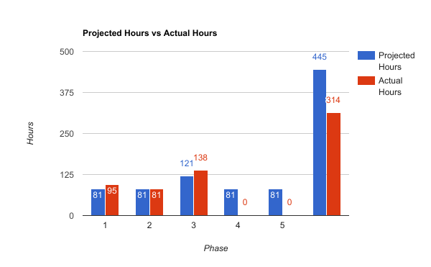

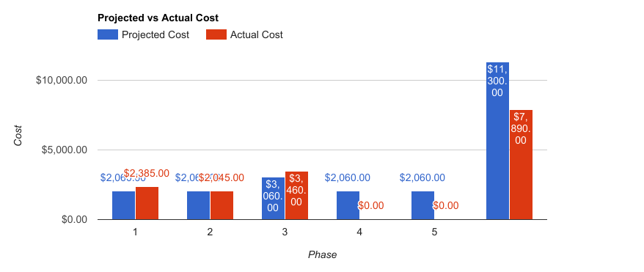

# Project Plan

## ~~Hold JAD 1 Meeting (2/8/17)~~ Completed

### On site

* ~~Discuss communication methods~~
* ~~Define customer requirements~~
* ~~Interpret project priorities~~
* ~~Discuss final product~~

## ~~Hold JAD 2 Meeting (2/22/17)~~ Completed

### On site

* ~~Adjust requirements if needed~~
* ~~Examine possible technologies to implement~~
* ~~Finalize definition of workflow object~~

## ~~Hold Prototype Meeting 1 (3/22/17)~~

### Teleconference

* ~~Discuss and finalize libraries we have chosen~~
* ~~Wireframe for simple workflow in all its states~~
* ~~Get feedback~~
* ~~Widget can accept JSON objects~~
* ~~Widget display implemented~~
* ~~Get feedback~~

## Hold Prototype Meeting 2 (Deadline: 4/13/17)

### TBD

* Widget given more functionality (modify/delete)
* CSS themed
* Error-handling
* Get more feedback for final product

# Statement of the Deliverables

In our next phase, we are working to allow 1 (one) or 2 (two) themes for the existing workflow, with the ability to switch for demonstration purposes. These themes will include the topics mentioned in our last meeting such as: SVG instead of images, a basic admin/user design for one theme, and will include the modified changes (upon approval) of the JSON object to distinguish the different views.

## 

## 

## Estimated Costs - Prototype 2 Due Date: 4/13/17

|  |  |  |  |
| --- | --- | --- | --- |
| **Task** | **Hours** | **Bill Rate** | **Total Cost** |
| Create additional views for widget | 40 | $25.00 | $1,000.00 |
| Improve functionality of widget | 40 | $25.00 | $1,000.00 |
| **Total Hours:** | 80 | $25.00 | $2,000.00 |

## Resources Outline

### What resources we will need from Northrop Grumman:

* Due to the nature of Northrop Grumman’s industry/clientele we understand that we will have no access to Northrop’s internal network and production data.
* Ty has provided us with:
  + Sample workflow object data
  + Application style guide
  + List of commercial libraries that Northrop Grumman has access to

### What resources we are supplying:

* We will provide a test environment to mimic how the widget will be deployed in production
* Any open source software that is needed for research/development purposes
* Slack channel
* GitHub repository

### What resources we will need from the instructor:

* At this time we do not require anything of the instructor.

## Gantt Chart / Task List

Please see the attached document for the gantt chart and task breakdown.

## 

## 

# Team Norms

## Reliability

Vortek Solutions strives to perform all of our tasks carefully and diligently, while still working in a swift manner, providing unparalleled reliability of our products. We take pride in our work, and reliability is of utmost importance.

## Commitment

Vortek Solutions is committed to our clients. We put in every effort to ensure all of our client’s needs are met, from the most prominent functional features to the smallest subtleties in design.

## Communication

At Vortek Solutions communication is key. We are in constant contact among each other and always ensure that the individual parts we are working on will amalgamate into one harmonious product. We also keep our clients up to date with our progress and send over updates as them come. We do not hesitate to ask any questions regarding our client’s needs and we are always open to questions and comments from our clients.

## Common Goal

Vortek Solutions strives to provide a product that is not just functional, but both beautifully built and intelligently designed. The ending result is a well built and carefully crafted product that is sure to leave our clients satisfied.